1-
LEARNING OUTCOMES (Problem & State-Space):
Rescue robot must reach emergency exit directed building graph. The initial state A, the goal points a G and original graph an taken from supplies this Lab.
States: A, B, C, D, E, F, G.
Actions; follow one is outgoing edge.
Successors; process is neighbors display left toward right list order.
Goal test; current node is equals G.
Depth; number traverse edges (A is depth 0).
Original step cost; 1 per Edge when discuss short hop count.
Counting rule; Node count so when remove from frontier processed, including G. Duplicate already process skip. Search stops as soon as G is processed.

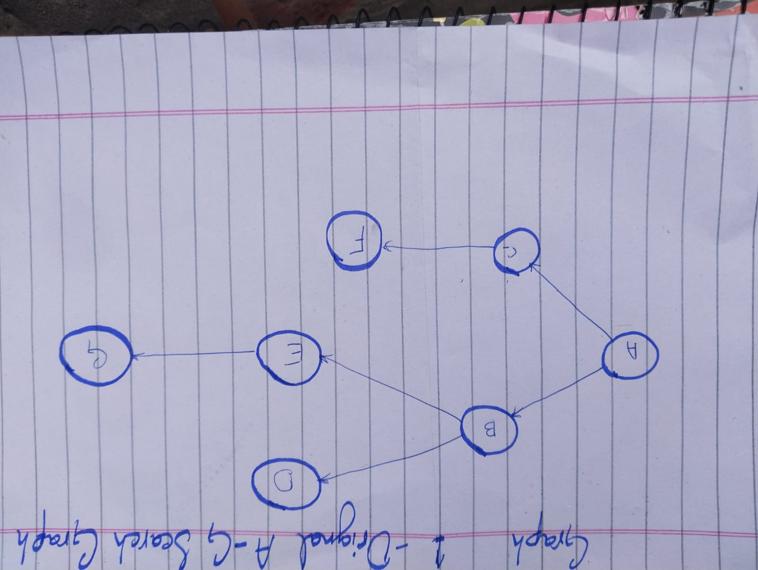
From | ORDER | FROM | ORDER
A | B,C | C | D,E
C | F | D | None
E | G | F | None
G | None

2-
Task 1 — Manual BFS and DFS frontier traces
BFS Trace:
1 | A | A | B,C
2 | B | A to B | C,D,F
3 | C | A to C | C,E,F
4 | D | A to B to D | E,F
5 | E | A to B to E | F,G
6 | F | A to C to F | G
7 | G | A to B to E to G

DFS Trace:
Step | Processed | Path | Bottom to Top
1 | A | A | C,B
2 | B | A to B | C,E,D
3 | D | A to B to D | C,E
4 | E | A to B to E | C,G
5 | G | A to B to E to G | C

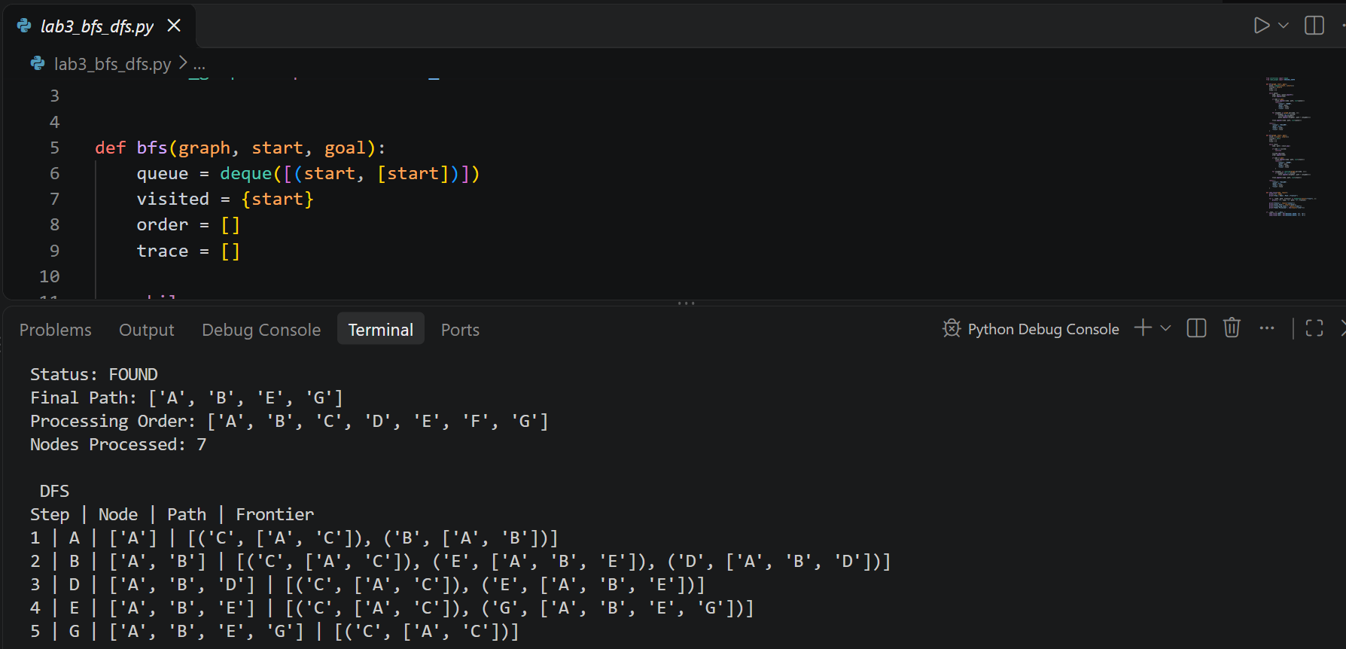
Explain The Matching Path:
Both algorithms return a same route because original graph contains only 1 A-to-G path. Processing order diff. BFS visits nodes by level as well as DFS follows the B branch deep before reach G. When A has successor (B, C) DFS pushes C first and B second so B is next node popped. The same reverse use B (E first then D)

Task 2-
DLS and IDDFS Required Limits;
DLS use DFS with maximum depth so check current path prevent a cycle as well as return 1 FOUND, CUTOFF or FAILURE. IDDFS run fresh DLS calls depths 0, 1, 2 until goal is found or allow max. is reach. Root A depth 0.
DLS;
LIMT | STATUS | PATH | ACTUAL ORDER | COUNT
1 | CUTOFF | None | A,B,C | 3
2 | CUTOFF | None | A,B,D,E,C,F | 6
3 | FOUND | A to B to E to G | A,B,D,E,G | 5
4 | FOUND | A to B to E to G | A,B,D,E,G | 5

Max depth | Status | Depth limits actually attempted | Total nodes processed
1 | CUTOFF | 0: CUTOFF; 1: CUTOFF | 1+3=4
2 | CUTOFF | 0: CUTOFF; 1: CUTOFF; 2: CUTOFF | 1+3+6=10
3 | FOUND | 0: CUTOFF; 1: CUTOFF; 2: CUTOFF; 3: FOUND | 1+3+6+5=15
4 | FOUND | 0: CUTOFF; 1: CUTOFF; 2: CUTOFF; 3: FOUND | 1+3+6+5=15
IDDFS: repeated search with maximum depths

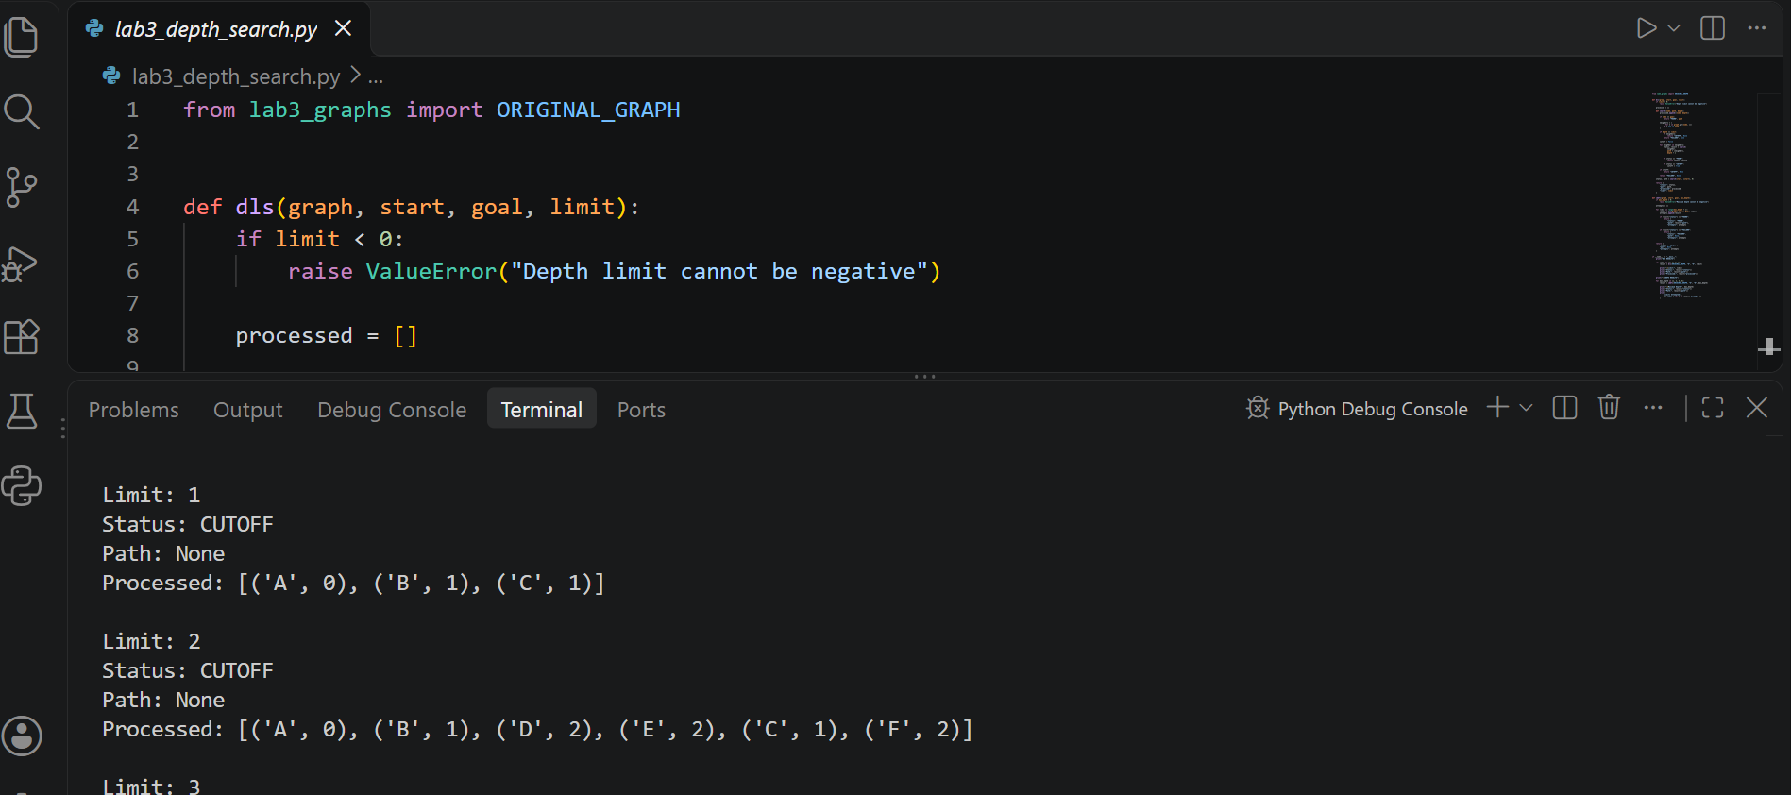
Interpretation and status rules
FOUND:
Goal was processed within depth limit
CUTOFF: At least one unvisited on the current path successor require go deep than allowe limit. FAILURE: All relevant branches exhausted no deep continuation remains. A CUTOFF limit 2 no proof that exit unreachable.
Repeated work: IDDFS process shallow nodes again each new limit. Why total work rises from 4, 10,15 node visit as well as visit check local each current path no global across depth limit otherwise valid later searche could be suppressed.

Task -3
UCS Fully Specified Weighted Extension:
Experiment keep each original vertex as well as edge and ADDS ONLY C to G. All Edge cost nonnegative travel-cost units. The excerpt reference weight set but does not list no. for each individual corridor so follow declared weight assignment use. It exact reproduce comparisons: 2 edges , cost 12 for BFS versus 3 edges , cost 3 UCS.

Graph 2 pics

Explicit Edge Weights;
A to B | A to C | B to D | B to E | C to F | C to G | E to G
1 | 6 | 4 | 1 | 4 | 6 | 1

UCS processing trace;
Step | Process | Cost (G) | Is a Path
1 | A | 0 | A
2 | B | 1 | A to B
3 | E | 2 | A to B to E
4 | G | 3 | A to B to E to G

UCS processing order:
A, B, E, G (4 processed nodes including goal)

BFS vs UCS on the identical weighted topology;
Algorithm | Path | Count | Cost Summed
BFC | A to C to G | 2 | 6+6=12
UCF | A to B to E to G | 3 | 1+1+1=3

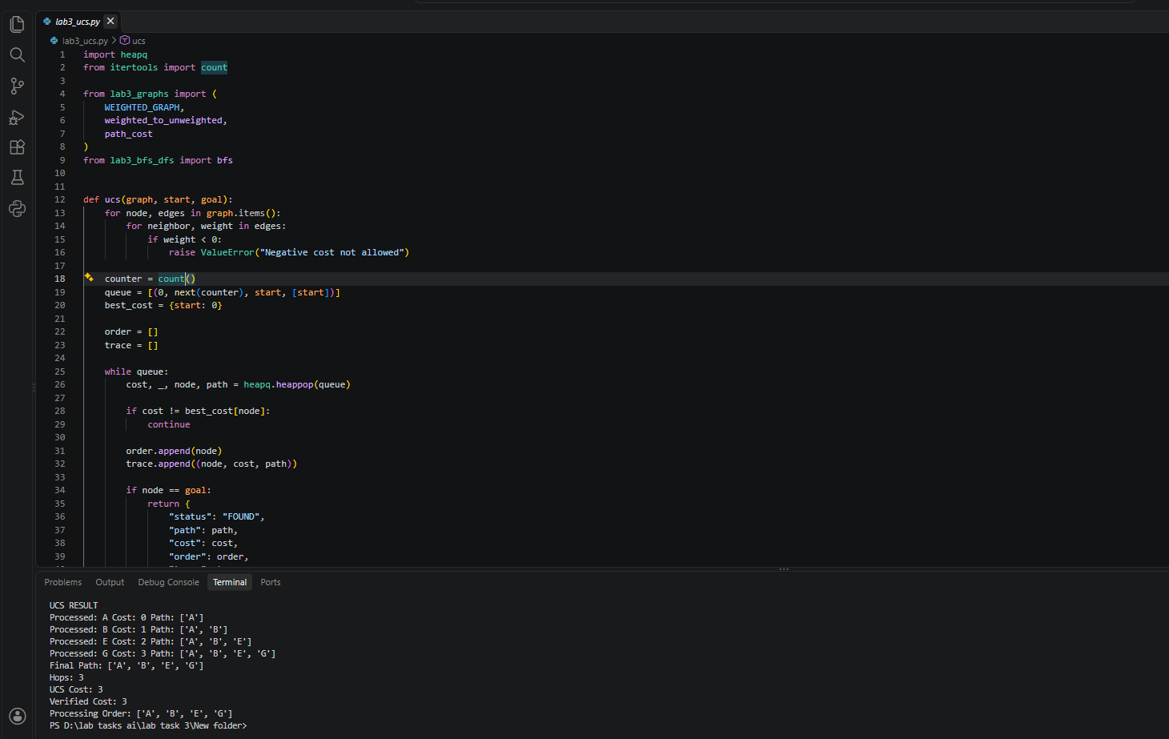

Reproducible Tests, Failures and Edge Cases
Eleven automate test pass use standard library unittest framework.
Test | Behavior | Resin
Start = goal = A | FOUND, Path: [A], Cost: 0 | Start node already goal
Goal Z absent; start A | FAILURE | Goal Z no exist the graph.
Goal Z; DLS limit = 2 | CUTOFF | Search stops depth 2 deeper path remain unexplore
Cycle A→B, B→A/C, C→B; goal C | FOUND, Path: A→B→C | Cycle checking infinite loops
Weighted graph with A→B = −1 | ValueError | UCS reject negative edge weights

8-
REFLECTION
Question 01
What did you learn today?
I learn BFS, DFS, DLS, IDDFS as well as UCS search graph find paths by use diff. methods.
Question 02
How will you apply this in a real AI system?
I use these algorithms robot navigation, route planning as well as find shortest as well as lowest cost path.
Question 03
What failed or surprised you?
DLS fail reach goal limits 1 as well as 2. I surprise that BFS found path with fewer edges but UCS found cheaper path.
Question 04
What would you do differently next time?
I want test larger graphs, different edge costs as well as more edge cases compare algorithms
9-
MEASURABLE OUTCOME;
I implemented as well as tested BFS, DFS, DLS, IDDFS, UCS.
- BFS; A → B → E → G
- DFS; A → B → E → G
- DLS; Found the goal at depth 3.
- IDDFS; Found the goal at depth 3.
- UCS; A → B → E → G (Cost = 3)
- Weighted BFS; A → C → G (Cost = 12)

BFS processed 7 nodes DFS processed 5 nodes original graph. UCS found minimum cost path weighted graph.

10-
FACULTY SELF-CHECK
Question 01
Did I start with the stated course problem and lecture outcome?
Yes, Start with emergency-exit graph problem as well as focused uninformed search algorithms
Question 02
Did students investigate or predict before the formal explanation?
Yes, Predict search paths as well as depth limit result before test the code.
Question 03
Did every student implement, trace, test, or evaluate something practical?
I implemented trace test search algorithms using Python.
Question 04
Did I require evidence of testing, comparison, or debugging?
Yes, the required code outputs, manual traces, comparison tables, edge-case testing.
Question 05
Did the activity remain aligned with the mapped CLO and cognitive level?
Yes, Tasks applied uninformed search algorithms practical graph
Question 06
Did the collected evidence match the measurable outcome?
Yes, Code outputs, Search traces, cost comparisons demonstrate required learning outcomes.

